**Introduction and Synopsis**

**The Mystery of ItaKai**

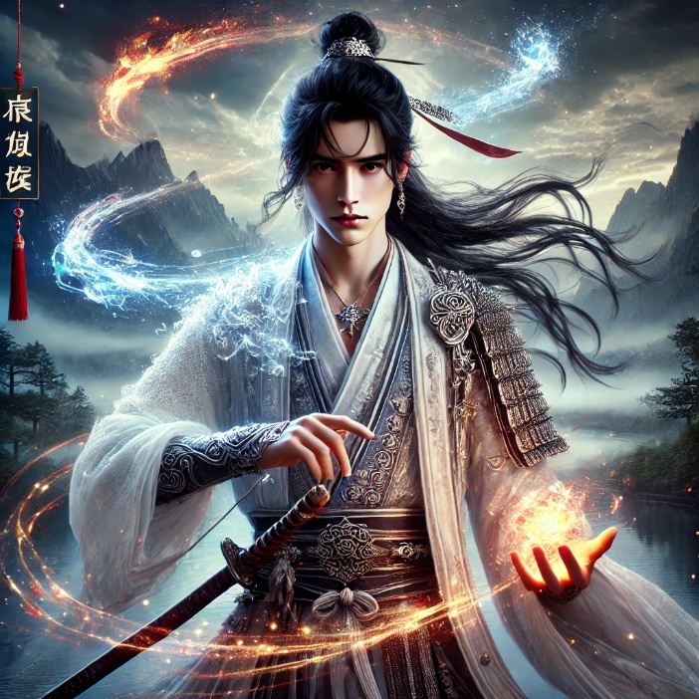

The game *"The Mystery of ItaiKai"* tells the story of Wei Jiang, a young master of the main Jiang family. He has just turned 18, which means it's time for serious and fundamental preparation as an heir to manage the island and, most importantly, to safeguard and preserve the main secret of ItaiKai — the knowledge of unity with nature. Now his father, Jinlun Jiang, the head of the island, and Xiu Xuan, the island’s chief guardian, begin lessons with the young master to teach him all the essential knowledge.

The training sessions went smoothly and peacefully until, for inexplicable reasons, outsiders arrived on the island. This became a significant threat to the island's secret, as no one beyond ItaiKai knows of the existence of this land, its people, or its power. However, to everyone's surprise, the newcomers arrived without bad intentions. Moreover, they show great friendliness toward the island's inhabitants, help them, and engage in communication. Especially noteworthy is Lyeotolv, the leader among the outsiders.

Wei Jiang became friends with Lyeotolv. The young master found it fascinating to hear about the world beyond the island, and Lyeotolv was more than happy to share tales about the kingdoms of the mainland. Gradually, Wei Jiang began to trust his new friend and his intentions to stay in ItaiKai forever. Because of this trust, he started sharing his studies, which neither his father nor his guardian knew about. Wei Jiang became deeply engrossed in the origins of the art of unity with nature and secretly began to gather ancient texts and books. Lyeotolv often helped him in this endeavor.

To Wei Jiang's disappointment, it soon became clear that the visiting guests were not as benevolent as they seemed, and Lyeotolv was not as simple as he appeared. Wei Jiang discovered that his friend had arrived searching for a power unknown to the mainland. The king of his country, Varsis Ruvokin, had sent a secret expedition to find something that would make him invincible and enable him to dominate other kingdoms. This was how Lyeotolv ended up on ItaiKai and learned about the power the island safeguarded. Now, he planned to deliver this knowledge to his king, which would reveal the centuries-old secret that Wei Jiang's ancestors had so carefully protected.

The young master was ready to do whatever it took to defend his people, their history, his father, and the secret passed down through generations.

Setting

All the events of the game take place on the island of ItaiKai. It is a small island with a single town, the estate of the main family—where the guardian's residence is also located—and a temple. The island features towering mountains and is entirely covered in forests, surrounded by an ocean too cold to swim in. The inhabitants primarily engage in fishing, hunting, running shops and taverns, farming, and growing crops, fruits, and vegetables. Life is typically calm and measured.

The head family are the protectors of the island and masters of the art of unity with nature. Ordinary residents possess this art at a minimal level, using it to better cultivate the land, grow food faster, and so on. The main family, however, are masters of this art, as are their apprentices. They are forbidden from killing animals, fishing, or harming nature in any way to maintain harmony. They wield the forces of nature—wind, fire, earth, and water—all of which are favorably inclined toward them, lending their powers to protect the island and ensure the prosperity of nature.

**Game Design**

This is a single-player game from a third-person perspective with an option to switch to a first-person view. *"The Mystery of ItaiKai"* is in the action, adventure, and fighting genres. Naturally, this is driven by the battles featured in the game, the study of the art of unity with nature, as well as uncovering the mysteries of this art, and searching for ancient texts that reveal more stories than the character is told by his father and mentor.

The game is also story-driven, as everything that happens in it is motivated by the narrative, which will be revealed to the player. Essentially, all actions from the very beginning are aimed at achieving two main outcomes: mastering the art of unity with nature completely and defeating the enemies to safeguard the secret.

The game's progression will unfold as follows: the game can be roughly divided into four parts:

1. **Introduction**: The player is introduced to the characters and the island, helping them understand who they are and where they are. The game's goal is explained—mastering the art of unity with nature. The initial training begins, focusing on mastering wind magic at a basic level. The first battle, organized by Wei Jiang's father and mentor, serves to enhance his skills.

This all takes place in the early part of the game, ensuring the player gets familiar with its core mechanics right from the start, including studying magic, meditation, harnessing its power, combat, and leveling up. This stage is not very long but effective and explains what is happening in the game and how it works.

1. **Early Stage**: There is unrest on the island—strangers from the mainland have arrived. Wei Jiang does not fully understand the reason behind his father's and the entire court's strong reaction. He interacts with the newcomer, Lyeotolv, and begins to think that he might not be so bad. Wei Jiang grows curious about the nature of the power they possess and starts searching for secret texts that are inaccessible to anyone except the guardian. Lyeotolv helps him with this endeavor. At this stage, Wei Jiang also begins learning to harness the power of water.

This stage is slightly longer. It includes more battles, further development of the storyline, and the introduction of a mystery. Additionally, the player becomes more immersed in the character's training, gaining a deeper understanding of the learning process and its significance.

1. **Main Section**: This stage also begins with searching for texts and training. However, during this phase, Wei Jiang and Lyeotolv uncover critical information about the origins of the power, its malevolent uses in history, and the methods behind them. The dark potential of the power is revealed. Disturbed by what he learns, Wei Jiang no longer wishes to delve deeper into the details.

Lyeotolv closely observes Wei Jiang's training during this time. At the beginning of this arc, the protagonist learns to master the power of earth, and by the end, the power of fire. Trust in the outsiders begins to grow among the island's inhabitants.

This is the longest arc, during which the player uncovers the core information about the story and can focus on improving their skills. The player also grows more accustomed to Wei Jiang's friend, Lyeotolv, and begins to trust him. All the arts are studied in this arc, each requiring more time due to their complexity. This allows the player to delve deeper into the mechanics of mastering the powers and solidifies their connection to the characters and the narrative.

1. **Conclusion**: The outsiders turn out to be traitors, a fact Wei Jiang discovers by chance. He immediately informs his father, who becomes angry with him. The guardian then shares with Wei Jiang an oral history passed down through generations—how, long ago, someone from outside their people nearly destroyed everything and everyone around by using the power with malicious intent.

The outsiders flee, and the player must fight them to prevent them from leaving the island and exposing the secret. The arc culminates in the protagonist's victory.

At the end of the game, the player sees that Wei Jiang has grown older and more serious. He has long since mastered all the arts at the highest level, symbolizing his transformation and readiness to lead and protect the island.

This arc is not very long, as it primarily focuses on revealing the history behind the great secrecy maintained by the island's leaders and the final battle against the enemies. Despite its brevity, it serves as a climactic resolution to the story, tying together the narrative threads and delivering a decisive and impactful conclusion. Skill development will not be possible at this stage.

In essence, the primary drivers of progression, based on everything mentioned, will be mastering the arts, searching for secret texts, and battles along the way. These elements form the core gameplay loop, ensuring a balance between exploration, learning, and action to keep the player engaged throughout the journey.

Key points can primarily be called the points of mastering the arts of air, water, earth, and fire. Also, the main points can be called the discoveries of texts: the text about the origin of the power, the text about its purposes and goals, the text about forbidden methods of use, the text about what can happen if the power is used incorrectly, the text about what a person should do and what they should follow to be in full harmony with the forces of nature. If we consider the main plot points, they are the arrival of outsiders, the discovery of texts about power, the betrayal, the story from the past, the main battle, and the victory.

Overall, the game will not be very long. Its completion will take between 4 to 7 hours, depending on the player, as there will be optional side quests available to improve skills (not mandatory).

Main characters: Wei Jiang, Jinlun Jiang, Xiu Xuan, Lyeotolv Bloom, Yanlin Jiang.

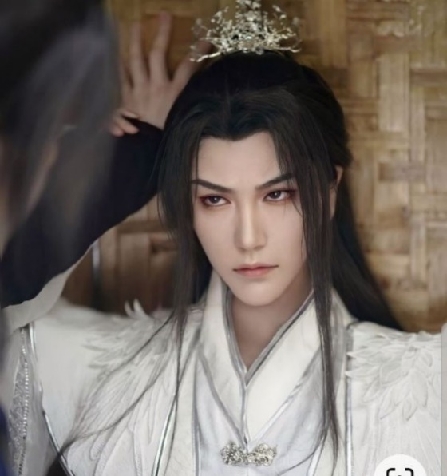

Wei Jiang

The main protagonist has just turned 18. A young master destined to take over leadership of the island in the future, following in his father's footsteps. He is capable, curious, and deeply interested in the world beyond the island, while also having a great love for his home and people. With great enthusiasm, he studies the power of nature and occasionally doesn't mind bending the rules established by the ruling court.

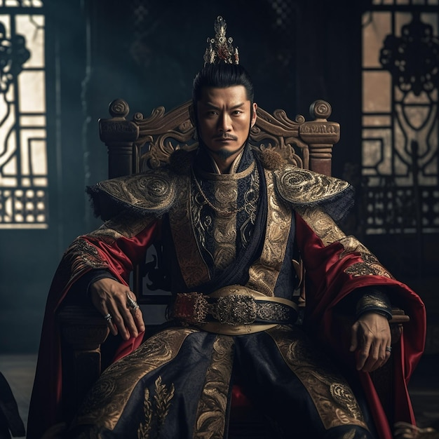

Jinlun Jiang

The head of the clan, the most skilled master of all the forces of nature. Strict and reserved, yet understanding and respectful toward others. He is demanding of his son but remains a good father, capable of imparting great wisdom. He is very wary and negative toward outsiders, opposing any contact with people from the mainland to avoid wars, their disharmony, and the negative influence on both individuals and the state of the world. Most importantly, he is focused on protecting the secret to prevent potential horrors.

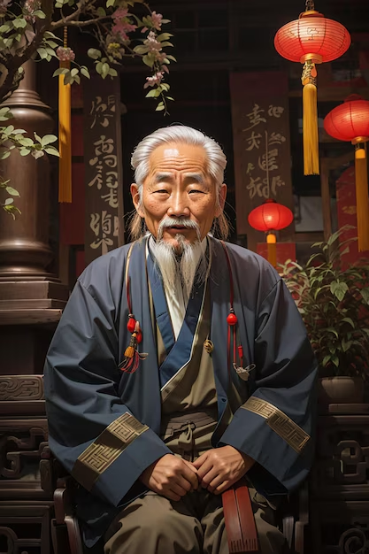

Xiu Xuan

The keeper of knowledge about unity with nature. Only he and the clan leader have access to all texts without exception, as well as to any knowledge about the power that exists in ItaiKai. He is also responsible for selecting a new keeper, passing on important unwritten knowledge, safeguarding all texts, and preserving them. Additionally, he is tasked with training the future clan leader in the arts of nature. Advisor to the clan leader on matters concerning the forces of nature.

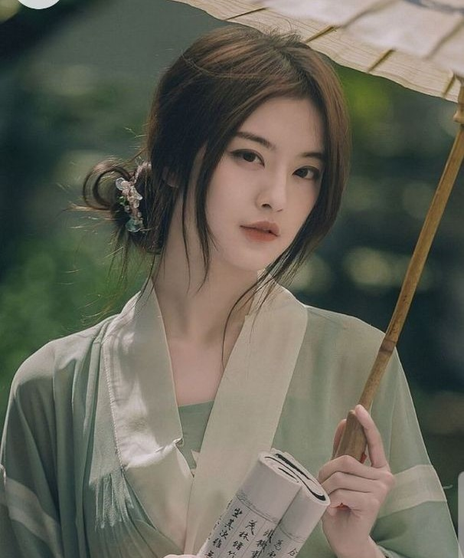

Yanlin Jiang

A childhood friend of Wei Jiang who grew up at court. She is one of the most skilled weapon masters, despite being younger than Wei Jiang. A diligent student of the court, she is well-mannered and obedient, never breaking the rules. She always tries to dissuade Wei Jiang from his reckless ideas, although she never succeeds. Occasionally, to prevent him from doing something truly foolish, she may join him. She does not trust Lyeotolv and dislikes the young master's friendship with him. In a few years, she is also set to begin studying the forces of nature.

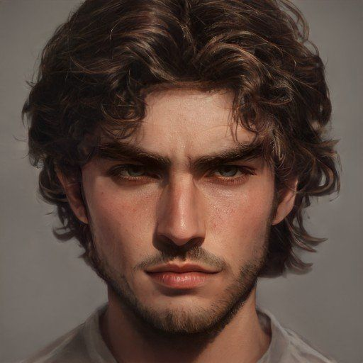

Lyeotolv Bloom

A resident of the country Tuwolor, ruled by Varsis Ruvokin. He arrives on the island after being sent by the king to seek a power that would make him invincible, no matter what. He ends up on the island due to a shipwreck in the ocean. Initially, he plans to leave almost immediately, but he discovers that the island holds an art unknown to the rest of the world, something unimaginable to those on the mainland. He decides to learn everything he can, steal the books, and return to the king. However, he is ultimately defeated by Wei Jiang.

**Tone**

The mood of the game will change as the story progresses. In the beginning, it will feature a relaxing world and storyline, with a very calm and cozy atmosphere. However, over time, it will become filled with greater mysteries, gradually becoming more tense and enigmatic. When Wei Jiang learns of his friend's betrayal, the game takes on a somber mood. At this point, the player will also learn why the secret has been so carefully guarded. A backstory will be revealed to the player, which will also carry a melancholic tone.

After a brief reflection, Wei Jiang makes an important decision, and the game shifts back to being tense as the final arc begins, featuring battles against the traitors. Naturally, the player will experience feelings of excitement, focus, tension, and the thrill of victory.

Overall, mystery and intrigue will be the dominant moods throughout the game. As for emotions, curiosity will prevail initially, later evolving (closer to the end) into a desire for revenge, protection of the island's secret, victory, and a sense of justice.

It is also important to highlight the atmosphere of the game world. A significant emphasis will be placed on nature, as it can be considered one of the most important characters in the story. The entire island will brim with the beauty of nature, from mist-covered mountain peaks to blooming cherry blossoms.

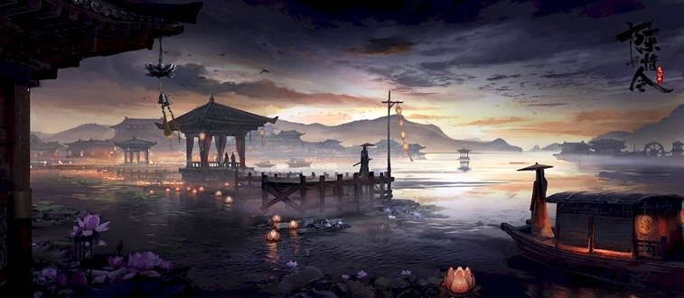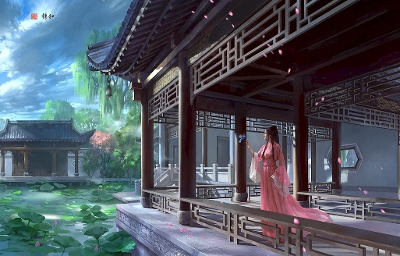

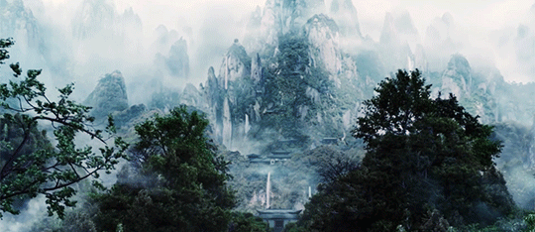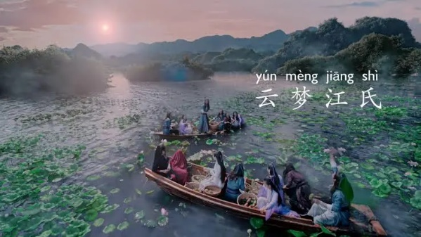

Due to the abundance of nature surrounding the characters, there will be a sense of harmony between human life and the natural world—a measured, very calm, and even quiet peaceful existence. Of course, battles, studies, dialogues, and uncovering secrets will intersperse this atmosphere to ensure the player doesn't grow weary of the serenity and can continue to appreciate the beauty of the world.

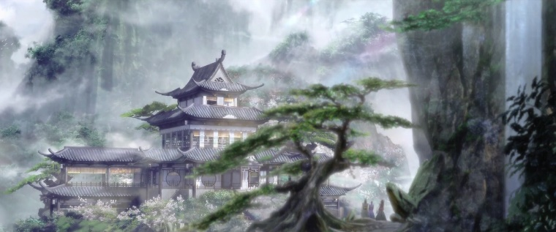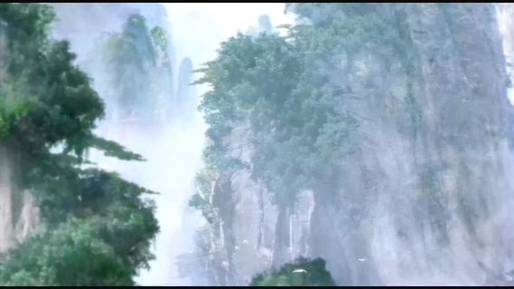

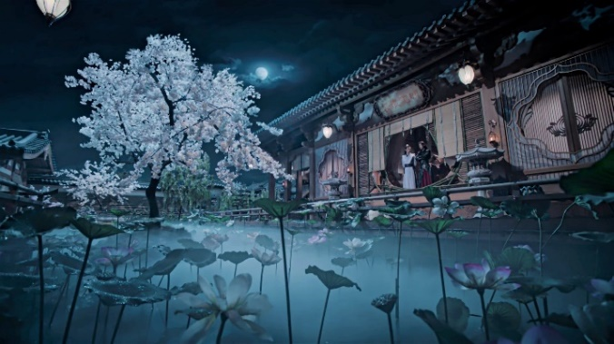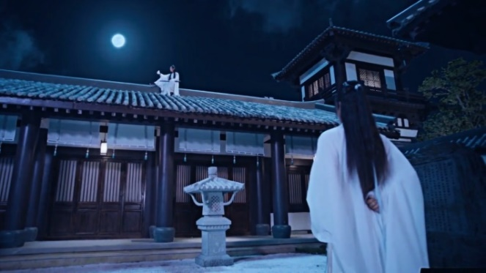

**Game Art Inspiration**

The greatest influence in creating this game was a series of books "Grandmaster of Demonic Cultivation" that later inspired a manhua, an anime, and even a drama. While the plot and characters are entirely original, the atmosphere we aim to convey in the game, the style of communication, and the harmony with nature are largely borrowed from this series.

Although there is magic in that series, in the game, the power preserved by the inhabitants of ItaiKai is not based on magic but on unity with nature. They do not control it as one would control magic; instead, they are in such harmony with it that nature becomes almost an extension of themselves.

It can also be said that the desire to create a certain atmosphere—originally inspired by the "Grandmaster of Demonic Cultivation" series—was further strengthened by traditional-style Chinese dramas.

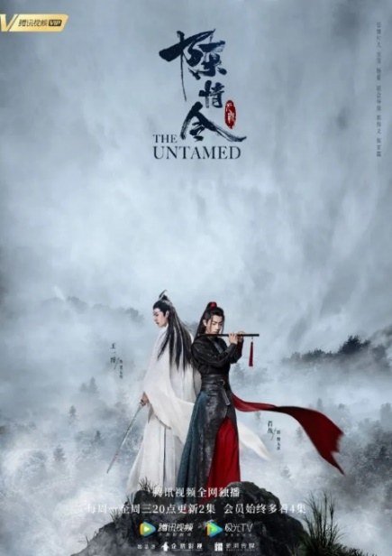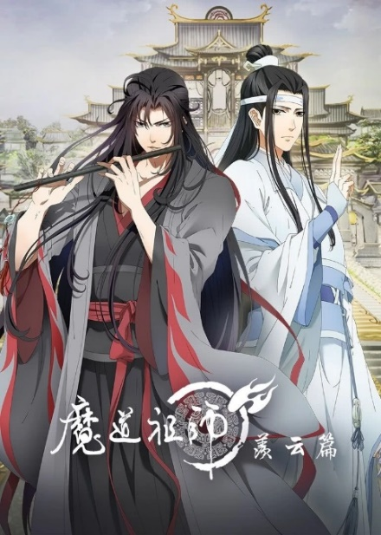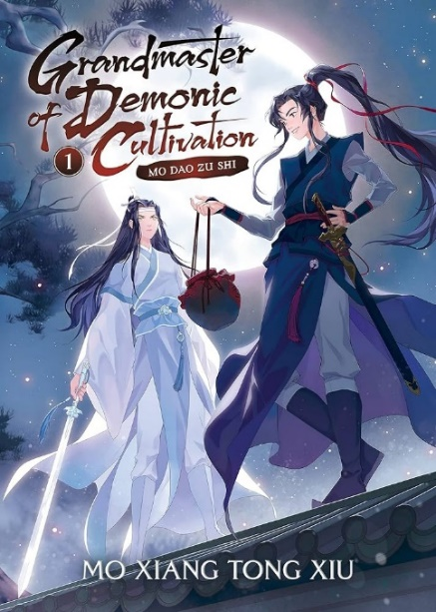

**Setting**

ItaiKai is a small island with a town on the shore and a main court further inland, where the island's leaders, their assistants, and warriors skilled in the forces of nature reside. Speaking about the town, it can be described as a place full of friendliness and warmth. The people live well, enjoy life, work, interact, and learn.

Adults mostly work as fishermen, hunters, farmers, growing food, making clothes, or running cafes and taverns where others can relax. Children study reading and writing, history, and laws, as well as practice meditation and concentration, which help them minimally utilize the forces of nature to assist in their everyday lives.

Anyone can volunteer to master the forces and undergo training at the main court, which involves living there, following the rules, and obeying their patrons' orders. This is considered very prestigious, and the pay is quite high. Still, few are willing to send very young children to the main court, especially since leaving the service without a valid reason is not permitted later, and those who serve must remain in the main court.

The town will appear only a few times in the game, during the arrival of the outsiders and in the final battle. While it won't be a major focus, visualizing it and showcasing the peaceful and beautiful lives of the people is crucial to emphasizing that preserving the secret ensures their happiness. This will strengthen the player's impression of the secret's significance and the need to protect it.

Additionally, the visualization of the town, along with the main court, will help establish the game's atmosphere, making it more memorable. The events of the game will unfold over several months, meaning the seasons will change throughout the story.

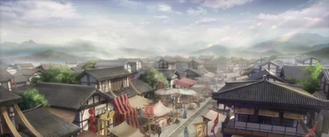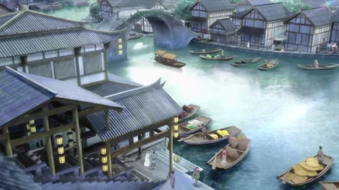

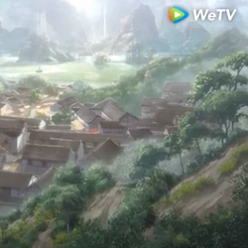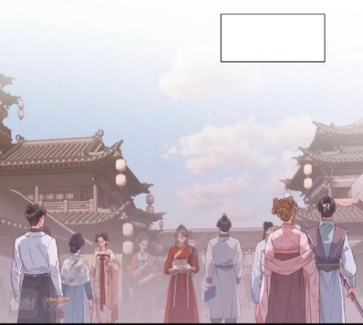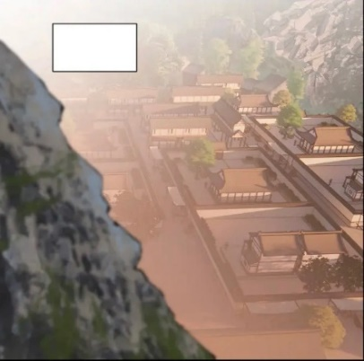

The main court is not only the residence of the island's ruling family but also a place where this family continuously works on self-improvement and enhancing their powers. They maintain harmony with nature, pay it their respects, train their abilities, and handle the economic affairs of the town.

They also handle all issues that arise among the people on the island: conflicts between individuals, accusations of criminal acts, economic and social problems, any concerns about crop yield and fertility, as well as the fears and worries of the people. Anyone living within ItaiKai can request help from a member of the ruling family to resolve their problem.

Additionally, within their residence live the apprentices, who undergo rigorous and fundamental training. They study sciences and master the forces of nature to a level sufficient not only to assist the people of ItaiKai but also to protect the island if needed.

The court has the strictest rules, the violation of which can result in severe punishment or even expulsion from the court's grounds. Prohibitions include eating meat, making loud noises, misusing power, disclosing secret information, killing animals, harming nature, showing disrespect, lying, skipping meditations, and much more.

These rules must be strictly observed to maintain the connection with nature and to keep the soul untainted, as this directly influences a person's harmony, which is inherently tied to their harmony with nature.

This is the very place where the main events of the game will unfold. The character will learn to fight and complete certain tasks within the walls of the main court. Additionally, most of the dialogues will also take place within its boundaries.

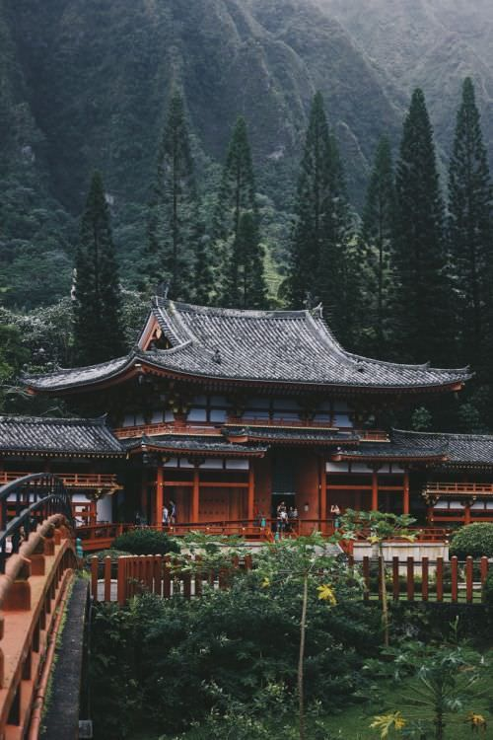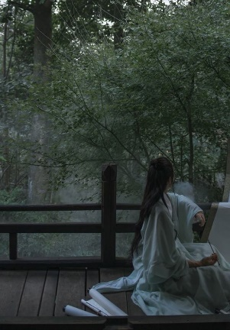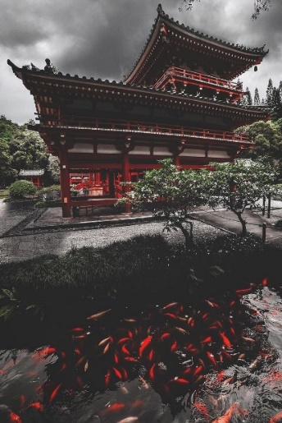

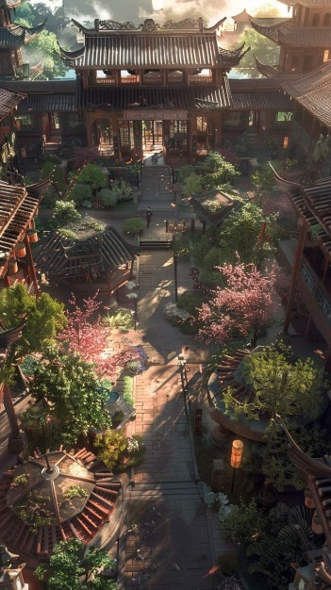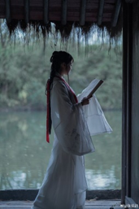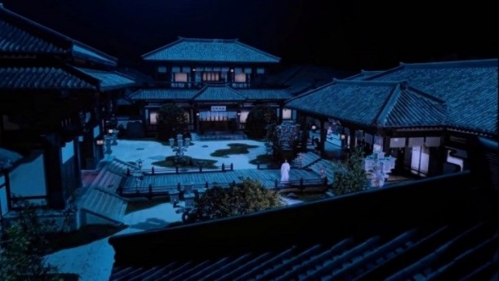

On ItaiKai, the summer season is sunny and warm, while in winter, it may snow. Rain is a common occurrence throughout the year. The people of ItaiKai hold great respect for all natural phenomena.

Interestingly, the islanders deeply value the traditions and culture of their homeland. Festivals are celebrated vividly, with everyone joyfully participating in the events and celebrations. People have a profound reverence for clothing, culture, visual arts, music, and dance.

The island also has a temple where anyone can express gratitude to the forces of nature and leave offerings as a sign of respect and appreciation.

This doesn’t significantly affect gameplay, but side visual elements, such as mentions of a festival celebration or a musician playing a bamboo flute, will enhance the game’s atmosphere, making it more memorable and authentic.

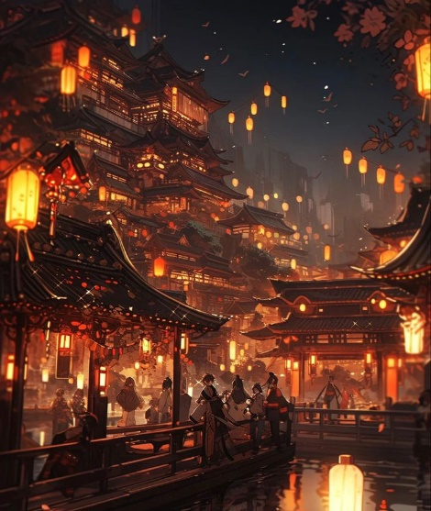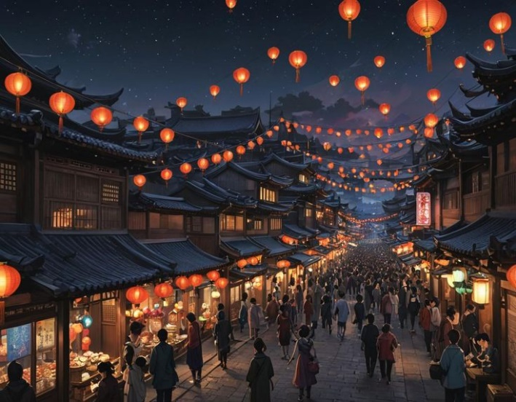

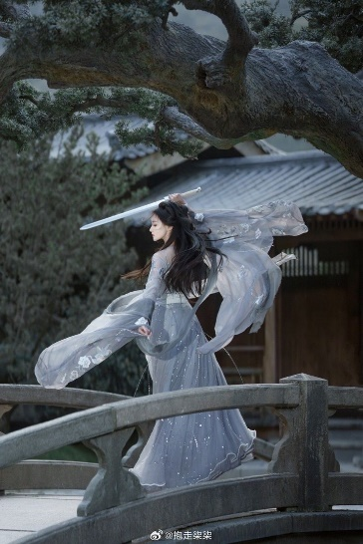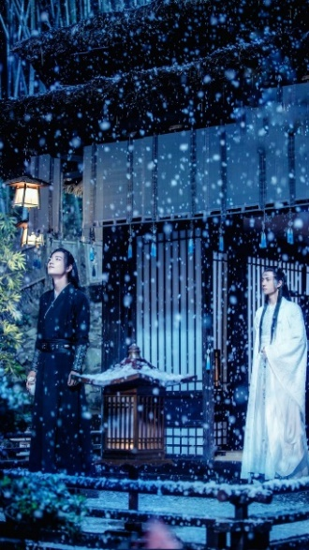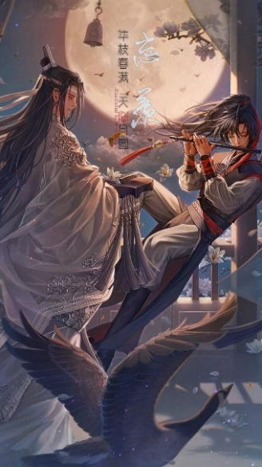

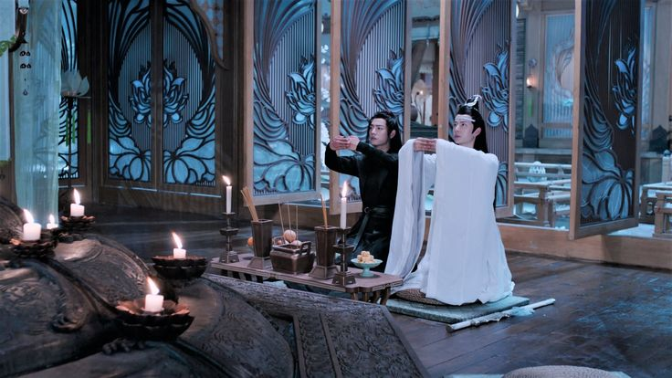

Of course, the island is brimming with nature. It is covered in forests and mountains, with numerous caves, surrounded by the ocean. The island itself is dotted with lakes, springs, waterfalls, and streams.

Rice, bamboo, potatoes, radishes, lotus flowers, and many other plants flourish on the island, forming a significant part of the people's diet. Additionally, the island is teeming with various animals, both domestic—such as donkeys, cows, and sheep—and wild, including rabbits, foxes, deer, and more.

The surrounding environment will play an important role both in maintaining the impactful presence of nature and in completing tasks. For example, meditation will be directly tied to the environment and the forces of nature.

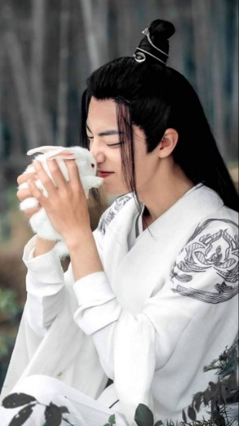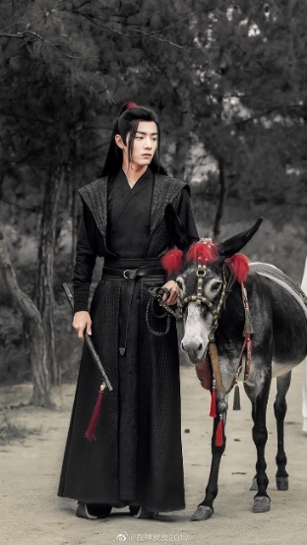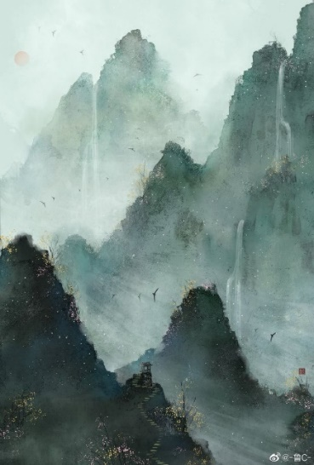

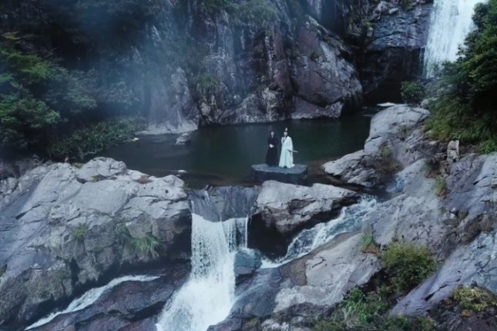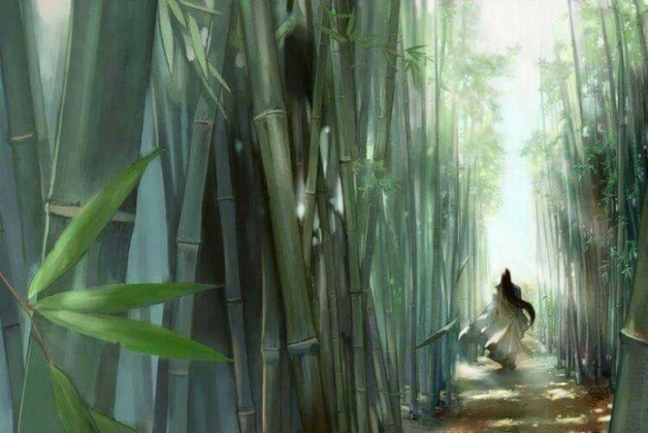

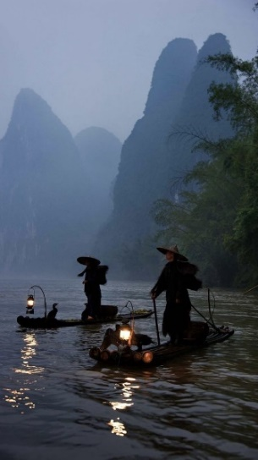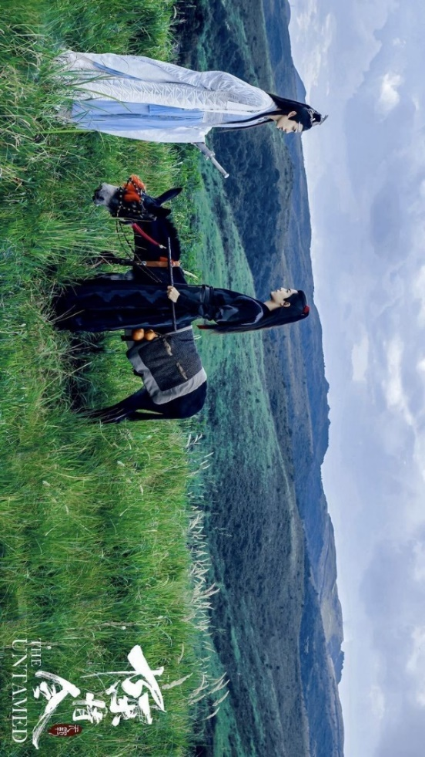

The game also features the residence of the guardian. This is where all the secret texts are stored. The main character will frequently visit this location, as it is the place where he will face various challenges left by the guardian to protect and secure the most important texts.

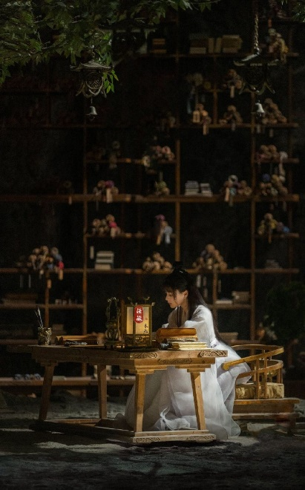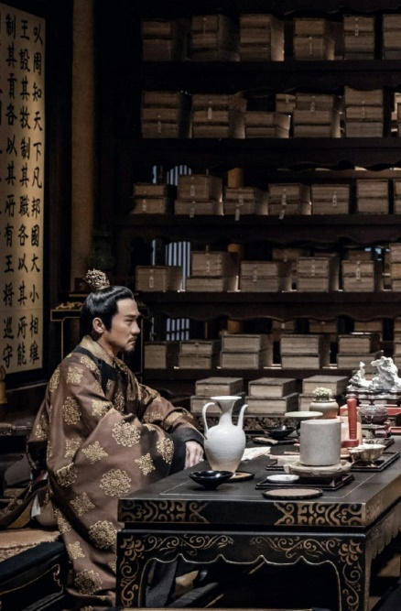

**Gameplay**

Although it might seem that the developed storyline could make it challenging to create a game where the player can fully enjoy the gameplay rather than just the story, this is not the case. The game will maintain a balance between narrative and gameplay, ensuring that the player not only observes but actively participates in the events of the game.

Each power will also have a final stage of its acquisition. Each power has an individual stage. Wind - balancing on a tightrope, water - finding a hidden object underwater without losing breath, earth - finding a rare plant, fire - passing through flames to the goal without burning. Each separate task will require different executions. They will appear only if the meditation is completed successfully. Water and earth - follow the trails left by the forces to find what is needed. Tightrope - use the A and D keys to stay balanced. Fire - rapid pressing of the spacebar. If the player does not complete the meditation well enough, the character will die during the final stage of acquiring the power, and the power acquisition stage will start over.

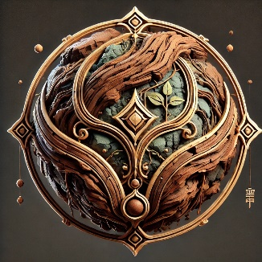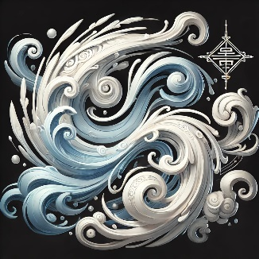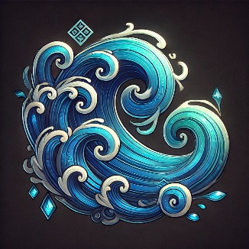

The symbols of the powers

In the final stage, there will also be enemies that need to be defeated specifically using the newly acquired power.

The second type of task the player will face involves finding secret texts. This stage consists of two parts: the first is solving puzzles, and the second is overcoming obstacles set by the guardian.

The first part is simple—solve puzzles to unlock the door leading to the texts. There will be several types of puzzles: finding a password, stealing a key, or sneaking through the door when the guardian opens it for a task, all without being noticed.

Let’s break down each type of puzzle. For the password, hints will be left in books and texts around the location. For example, the room may contain many letters, but only a few will have highlighted letters. These letters form a word that serves as the password. The player will need to examine all the letters, identify the highlighted ones, and enter them into the door.

To use the key, the player must steal it from the guardian, requiring patience and precision. The player must wait for the right moment to act and ensure they remain undetected.

In one scenario, Wei Jiang notices that the guardian is busy with papers and that one of the doors is open. The player must sneak past the guardian without being seen.

Beyond the doors, the player will encounter guards protecting the texts. These guards are creations of the guardian, entirely formed using the forces of nature. Different opponents require different techniques to defeat them (for example, a wind guard can only be defeated with the power of wind). After defeating all the guards, the player reaches the text and reads it.

The game will also feature a small interactive element involving decision-making. This will be part of Wei Jiang's training, planned by his father. During the game, while training, three people will approach Wei Jiang and his father with different problems. Wei Jiang will need to help them by choosing between two possible solutions.

At the end of the game, the player will learn whether they successfully helped the person resolve their issue. Decisions will be made by clicking the left mouse button.

The first person will say they cannot decide what is best for their son: to send him for training and service in the main court, which the son does not want, or to let him decide for himself, even though the son is quite immature. If the player chooses to send him to the court, they will learn at the end that the boy performed poorly, constantly broke rules, and is likely to be expelled. If the player chooses to let him decide for himself, they will find out later that the boy pursued music, discovered a great talent for it, and showed strong determination.

The second person will ask for help resolving a conflict with a neighbor over a piece of land. One wants to grow fruit there, while the other wants to raise rabbits. If the player chooses rabbits, they will later learn that the idea failed miserably because the rabbits multiplied too quickly, and there was no way to manage or sell them (the neighbor had planned to keep them in captivity for breeding and meat sales). If the player chooses fruit, they will discover that the orchards flourished, the fruit is sweet, and everything worked out well.

The third person will ask for a divorce from their spouse, saying they are no longer happy together. Their children have their own families, and now the couple feels bored and unfulfilled. If the player agrees to the divorce, they will later learn that the couple fell into even greater despair. If the player refuses, they will find out that the couple overcame this phase and started enjoying life together again.

All decisions and actions are aimed at maintaining the values that should exist on the island (for example, family), adhering to the rules of the court (the young lord cannot decide in favor of killing animals), and ensuring the freedom of choice for each individual to maintain their inner balance.

Skill upgrade tasks are optional and can be completed during the few moments in the game when the player is not strictly following the storyline but is given some freedom of choice. A couple of times throughout the game, instead of the usual transition between tasks as the story progresses, the player will gain control of the character and the opportunity to freely explore the court. During these moments, they can take on a few side quests or simply choose to continue the story.

Side quests will primarily consist of battles against various monsters created by the person offering the task. Completing these quests will increase the hero's skill in the forces they used during the fight.

There will be 4 tasks from the father in the game. Essentially, these are battles with rewards in the form of swords at the end. These tasks will be inserted into the storyline somewhat randomly, as they will have little impact on the main plot. These battles will take place in forests, caves, and near bodies of water.

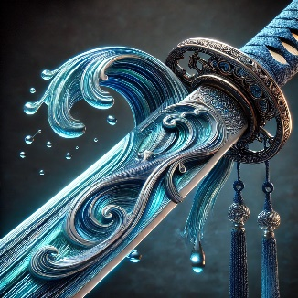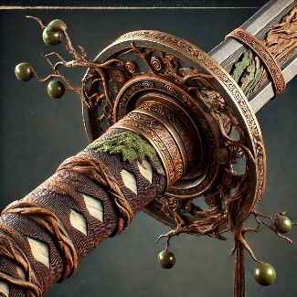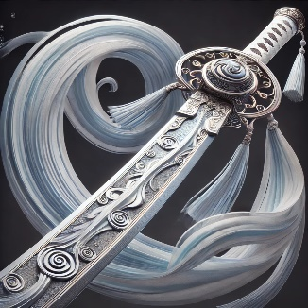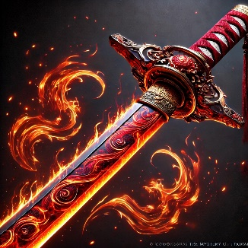

The final battle will be different, as it will be against people who have weapons beyond swords—cannons mounted on a ship. The cannon fire can only be avoided by using the forces of nature. Fighting against the enemies can be done with either a sword or the powers the protagonist has mastered. The battle will take place both on the ship and partially in the town.

The final boss, Lyeotolv, will engage in a sword fight with Wei Jiang. The mechanics will be like the final battle in *Uncharted 4*. However, during the fight, Wei Jiang will also be aided by the forces of nature, making him more effective in combat. But this does not mean the battle will be easier, as Lyeotolv began studying the island's powers after his arrival. However, instead of using them correctly, he resorted to forbidden methods, making the battle more challenging.

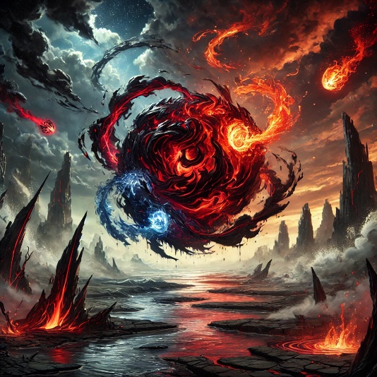

The player will face forces they have not encountered before, adding a layer of unpredictability. The battle will also incorporate mechanics from the training sequences, such as balancing, which must be combined with combat, and so on. This will make the fight dynamic, requiring skill and adaptability from the player.

When the player first learns a power during training, they gain 2 skill points in mastering it. Each subsequent story battle will grant an additional 1 skill point. Optional side quests will reward 0.5 skill points each. The maximum skill level is 20.

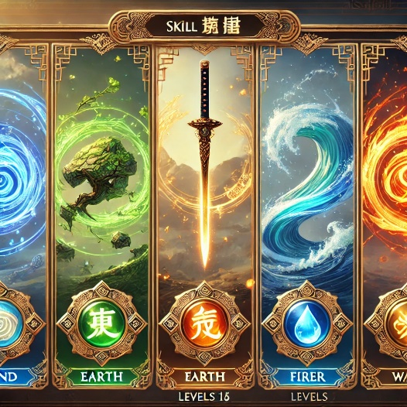

Approximate visual of the power skill system

The sword is a separate skill that develops differently. The maximum skill level is 20. The player must maintain a balance between skills and develop all of them, as magic and the sword will be needed in the final battle.

Sword skills will primarily increase differently. Main story tasks will grant 0.5 skill points, while optional side quests will grant 1 skill point each.

The character's inventory will consist solely of the four types of magic, which can be easily and quickly switched between by pressing F, G, H, T. Additionally, the inventory can hold one sword. Through tasks given by the father, the player can obtain four different types of swords, each of which increases the strength of a specific force of nature by 10%.

The will be no option for blocking attacks, but during the fights, the player will be able to find health icons around the location, each of which gives 25%.

The game will include a health system. However, there will be no stamina bar, as the character's strength is logically sustained by nature and its unity with it. Similarly, there will be no magic bar, as meditation ensures the character's connection with the forces of nature, meaning they will always be available to the character.

**Challenges**

Of course, there will be multiple challenges during the creation process. Since the story in this game is very important, it is essential to show that Wei Jiang and Lyeotolv truly became friends and trusted each other, so that Lyeotolv's betrayal later feels like a genuine blow to the player and comes as a surprise. It is also important to emphasize, not just in dialogues but also in subtle details, how significant the island's secret is to its inhabitants and the leader, as well as how crucial it is to protect it.

These elements are necessary for the player to truly feel the game's atmosphere and believe in everything happening for better immersion. This way, the story will have a genuine impact on the outcome and attract players with its depth and emotional engagement.

It is crucial to do everything possible to ensure that the game does not visually resemble MMO RPGs during battles and other moments when the player controls the character. Characters in such games are often designed in an Eastern style. In *"The Mystery of ItaiKai,"* special attention must be given to character and environment design to eliminate any resemblance to the visual style of MMO RPGs.

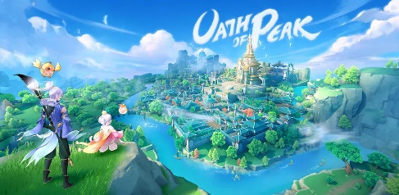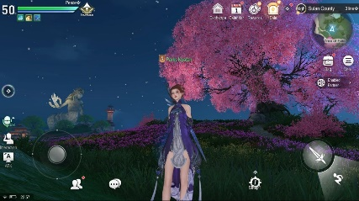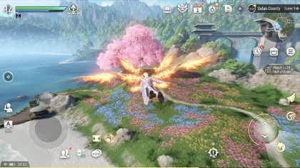

Instead, the game should take a more "Hogwarts Legacy" approach to camera perspective, design quality, and atmosphere. It should not resemble animations in Eastern styles (such as anime). The goal is to create a distinct, immersive aesthetic that aligns with the game's narrative and world-building while maintaining a polished and cinematic feel.

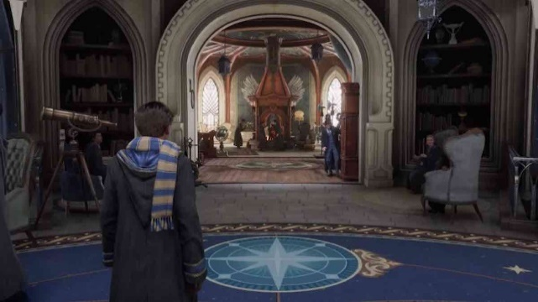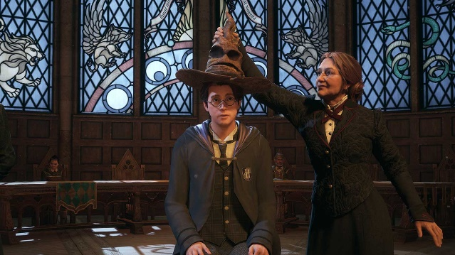

It is also crucial to ensure the game's difficulty level is well-balanced. The player should not feel bored, but at the same time, they should be able to overcome challenges without needing a million attempts. This balance will keep the gameplay engaging while avoiding frustration, ensuring a smooth and enjoyable experience.

**Target Market**

The target audience is people aged 14 and older who enjoy action-packed games around a specific theme. It is particularly advantageous that, with the chosen atmosphere and the character's appearance in a traditional Chinese style, the game can attract one of the largest and most engaged audiences — China. This also extends to nations with similar visual traditions, such as Korea or Japan. These are large markets that can generate significant revenue. Especially considering that, while the game will likely be more appealing to Eastern players, it is also expected to capture the interest of Western audiences.

The theme of sword combat is very popular, which will also boost the game's appeal. For players who value story, the game can be highly engaging due to its logical and emotionally driven narrative, as well as its intriguing characters.

The game will also appeal to fans of dramas, traditional Chinese atmosphere, and works by Mo Xiang Tong Xiu. This is because the game's world is inspired by these motifs, largely reflects and supports them, and strives to convey the same vibe.